***EXPERIMENT NUMBER :2 BELOW IS 1***

AIM: Write a program for implementing data pre processing methods on students and label data sets and construct a 3d data

@ SE NICHE TK COPY

Refernce:

<https://www.youtube.com/watch?v=12eWvSvOqF4>

experiment number 2:

im:

Implement data cube for data warehouse on 3-dimensional data

SOFTWARE REQUIRED: : Open source Weka 3.8, Python

Description:

We need to create a Weather table with training data set which includes attributes like outlook, temperature, humidity, windy, play.

Procedure: Steps:

1) Open Start - Programs -Accessories - Notepad

2) Type the following training data set with the help of Notepad for Weather Table.

@relation weather

@attribute outlook {sunny,rainy,overcast}

@attribute temparature numeric

@attribute humidity numeric

@attribute windy {true,false}

@attribute play {yes,no}

@data

sunny,85.0,85.0,false,no

overcast,80.0,90.0,true,no

sunny,83.0,86.0,false,yes

rainy,70.0,86.0,false,yes

rainy,68.0,80.0,false,yes

rainy,65.0,70.0,true,no

overcast,64.0,65.0,false,yes

sunny,72.0,95.0,true,no

sunny,69.0,70.0,false,yes

rainy,75.0,80.0,false,yes

3) After that the file is saved with .arff file format.

4) Minimize the arff file and then open Start -Programs - weka-3-4.

5) Click on weka-3-4, then Weka dialog box is displayed on the screen

6) In that dialog box there are four modes, click on explorer.

7) Explorer shows many options. In that click on ‘open file’ and select the arff file

8) Click on edit button which shows weather table on weka

Pseudo-code:

# Step 1: Create and save the training data set using Notepad

weather_data = """

@relation weather

@attribute outlook {sunny,rainy,overcast}

@attribute temperature numeric

@attribute humidity numeric

@attribute windy {true,false}

@attribute play {yes,no}

@data

sunny,85.0,85.0,false,no

overcast,80.0,90.0,true,no

sunny,83.0,86.0,false,yes

rainy,70.0,86.0,false,yes

rainy,68.0,80.0,false,yes

rainy,65.0,70.0,true,no

overcast,64.0,65.0,false,yes

sunny,72.0,95.0,true,no

sunny,69.0,70.0,false,yes

rainy,75.0,80.0,false,yes

"""

with open('weather_dataset.arff', 'w') as file:

file.write(weather_data)

# Step 2: Open Weka Explorer

# Assuming Weka is installed in the 'Weka-3-4' directory

weka_path = 'C:\\Program Files\\Weka-3-4\\weka.jar'

# Launch Weka Explorer using the command line

command = f'java -cp {weka_path} weka.gui.explorer.Explorer'

os.system(command)

# Step 3: Load ARFF file in Weka Explorer

# This step requires user interaction in the Weka GUI.

# User needs to open the file using the Weka Explorer.

# Step 4: Perform data cube operation (e.g., grouping, aggregation)

# Python script using Pandas or any other library can be used for this purpose

# The exact operations will depend on the specific analysis or aggregation you want to perform.

# Step 5: Save the results if needed

# Again, Python script can be used for saving the processed data.

# Step 6: End

Flow Diagram:

+------------------------+

| Start |

+------------------------+

|

v

+------------------------+

| Create and Save ARFF |

| File with Notepad |

+------------------------+

|

v

+------------------------+

| Open Weka Explorer |

+------------------------+

|

v

+------------------------+

| Load ARFF file in |

| Weka Explorer |

+------------------------+

|

v

+------------------------+

| Perform Data Cube |

| Operations (Python) |

+------------------------+

|

v

+------------------------+

| Save Processed Data |

+------------------------+

|

v

+------------------------+

| End |

+------------------------+

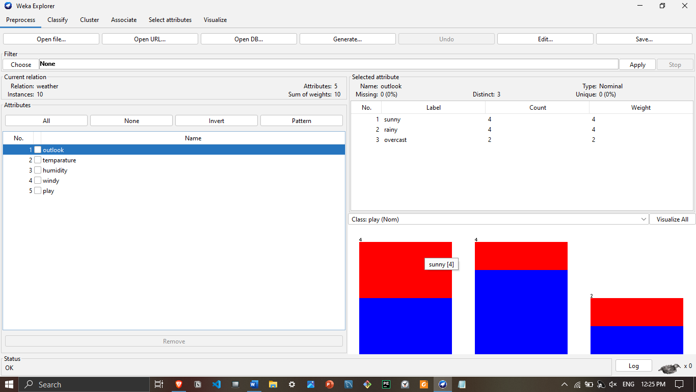

EXPERIEMENT NUMBER : 1

Aim: Data preprocessing methods on student and labor datasets.

SOFTWARE REQUIRED: Open source Weka 3.8, Python

We need to create an Employee Table with training data set which includes attributes like name, id, salary, experience, gender, phone number.

Procedure:

Steps: 1) Open Start Programs Accessories Notepad

2) Type the following training data set with the help of Notepad for Employee Table.

@relation employee

@attribute name {x,y,z,a,b}

@attribute id numeric

@attribute salary {low,medium,high}

@attribute exp numeric @attribute gender {male,female}

@attribute phone numeric

@data

x,101,low,2,male,250311

y,102,high,3,female,251665

z,103,medium,1,male,240238

a,104,low,5,female,200200

b,105,high,2,male,240240

3) After that the file is saved with .arff file format.

4) Minimize the arff file and then open Start Programs weka-3-4.

5) Click on weka-3-4, then Weka dialog box is displayed on the screen.

6) In that dialog box there are four modes, click on explorer.

7) Explorer shows many options. In that click on ‘open file’ and select the arff file

8) Click on edit button which shows employee table on weka

Pseudo-code:

# Step 1: Create and save the training data set using Notepad

employee_data = """

@relation employee

@attribute name {x,y,z,a,b}

@attribute id numeric

@attribute salary {low,medium,high}

@attribute exp numeric

@attribute gender {male,female}

@attribute phone numeric

@data

x,101,low,2,male,250311

y,102,high,3,female,251665

z,103,medium,1,male,240238

a,104,low,5,female,200200

b,105,high,2,male,240240

"""

with open('employee_dataset.arff', 'w') as file:

file.write(employee_data)

# Step 2: Open Weka and load the ARFF file

# Assuming Weka is installed in the 'Weka-3-4' directory

weka_path = 'C:\\Program Files\\Weka-3-4\\weka.jar'

arff_file_path = 'path_to_your_saved_arff_file\\employee_dataset.arff'

# Launch Weka Explorer using the command line

command = f'java -cp {weka_path} weka.gui.explorer.Explorer'

os.system(command)

# Step 3: Manually load the ARFF file in Weka Explorer

# This step requires user interaction in the Weka GUI.

# Further data preprocessing steps can be performed using Weka Explorer.

Flowchart:

+---------------------+

| Start |

+---------------------+

|

v

+---------------------+

| Create ARFF file |

| with Notepad |

+---------------------+

|

v

+---------------------+

| Save ARFF file |

| (.arff format) |

+---------------------+

|

v

+---------------------+

| Open Weka Explorer |

| |

+---------------------+

|

v

+---------------------+

| Load ARFF file in |

| Weka Explorer |

+---------------------+

|

v

+---------------------+

| Weka Explorer |

| Data Preprocessing |

| (User Interaction) |

+---------------------+

|

v

+---------------------+

| End |

+---------------------+